|  |  |  |
| --- | --- | --- |
| http://www.hcmus.edu.vn/images/stories/logo-khtn2009_transparency.png | **CS426- Mobile Device Application Development** |  |

Class: APCS 2017

Date: June 14-17, 2018 (72 hours)

**Mini Project 1**

**Personal Report**

**Student ID: 1751113**

**Student’s full name: GOI CHÍ TRUNG**

**Email: chitrung030599@gmail.com**

**Tel: 0928555928**

# Project Self Assessment

In this section, each student should personally evaluate his or her own effort to complete the project.

* For each feature, please determine the level of complexity (1-Very simple, 2-Simple, 3-Normal, 4-Difficult, 5-Very difficult) and level of completeness (100%).

|  |  |  |
| --- | --- | --- |
| **Feature** | **Complexity** | **Level of completeness**  **(100%)** |
| (A) | (B) | (C) |
| Recycle View for portrait mode | 3 | 100% |
| Fragment for portrait mode | 3 | 100% |
| Connect with an online database using firebase real time database and storage | 4 | 50% |
| UI for portrait mode | 3 | 100% |
| Being able to upload and get image from database | 3 | 20% |
| Using youtube API to get a video from youtube | 4 | 100% |
| Create 2 activities with back and forth for portrait mode | 4 | 100% |
| Custom divider for recycle view | 2 | 100% |
|  |  |  |

# Advanced Features

Connect with an online database using firebase real time database and storage

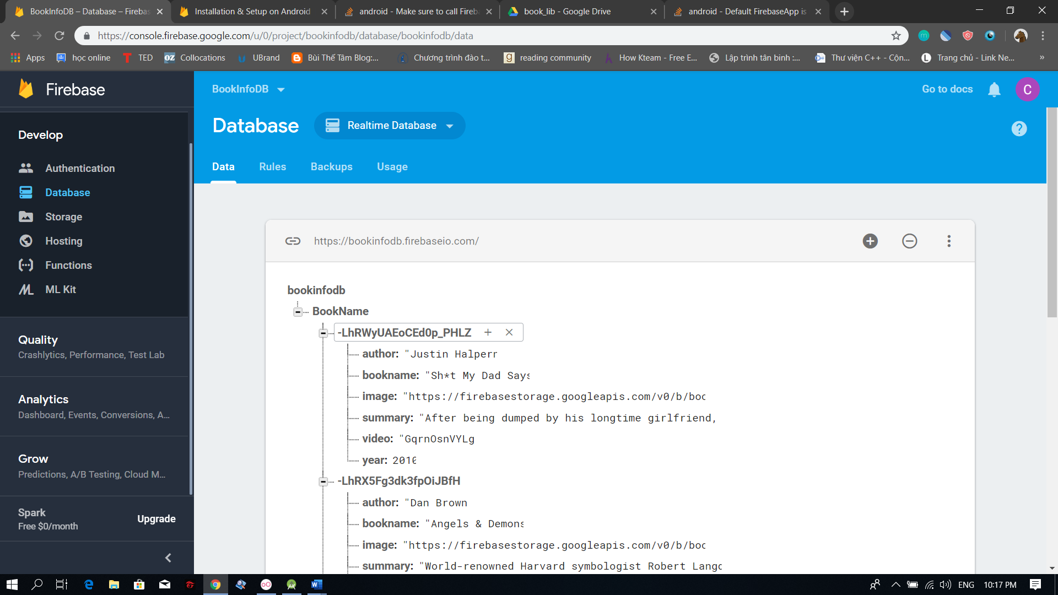

Being able to upload and get image from database

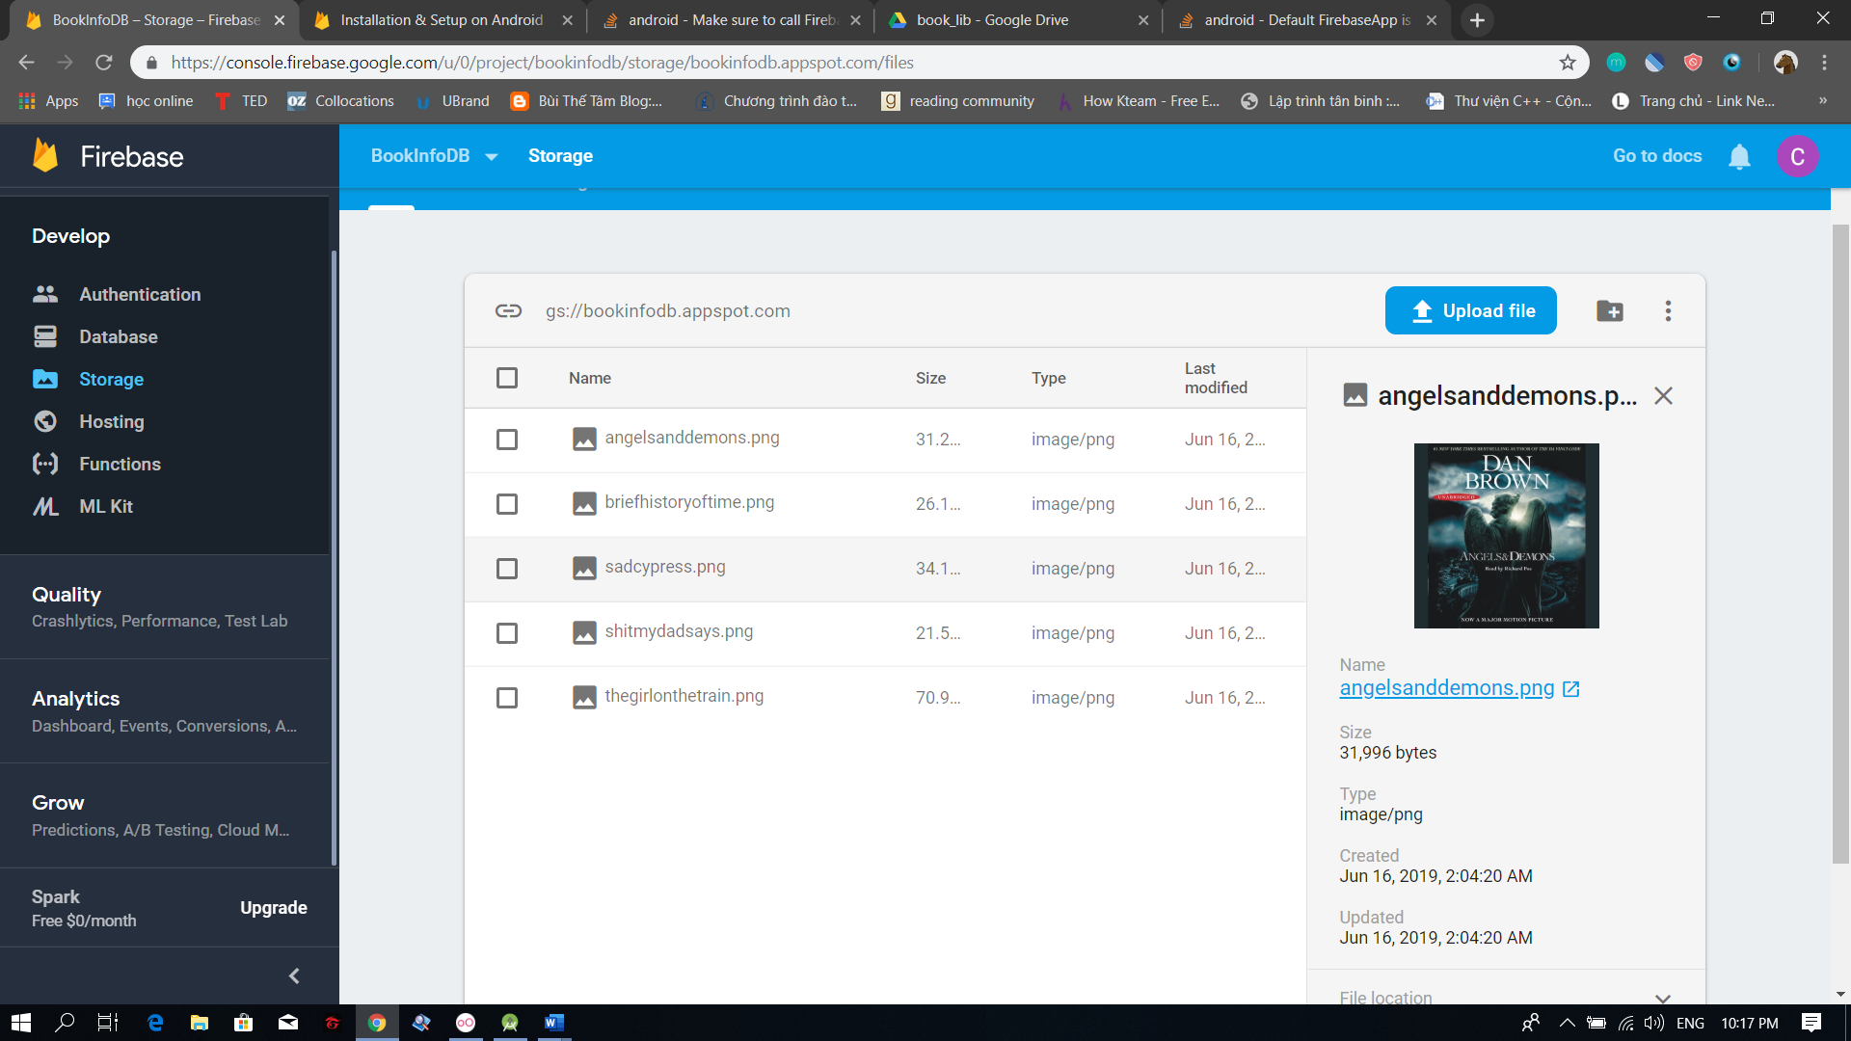

Using youtube API to get a video from youtube

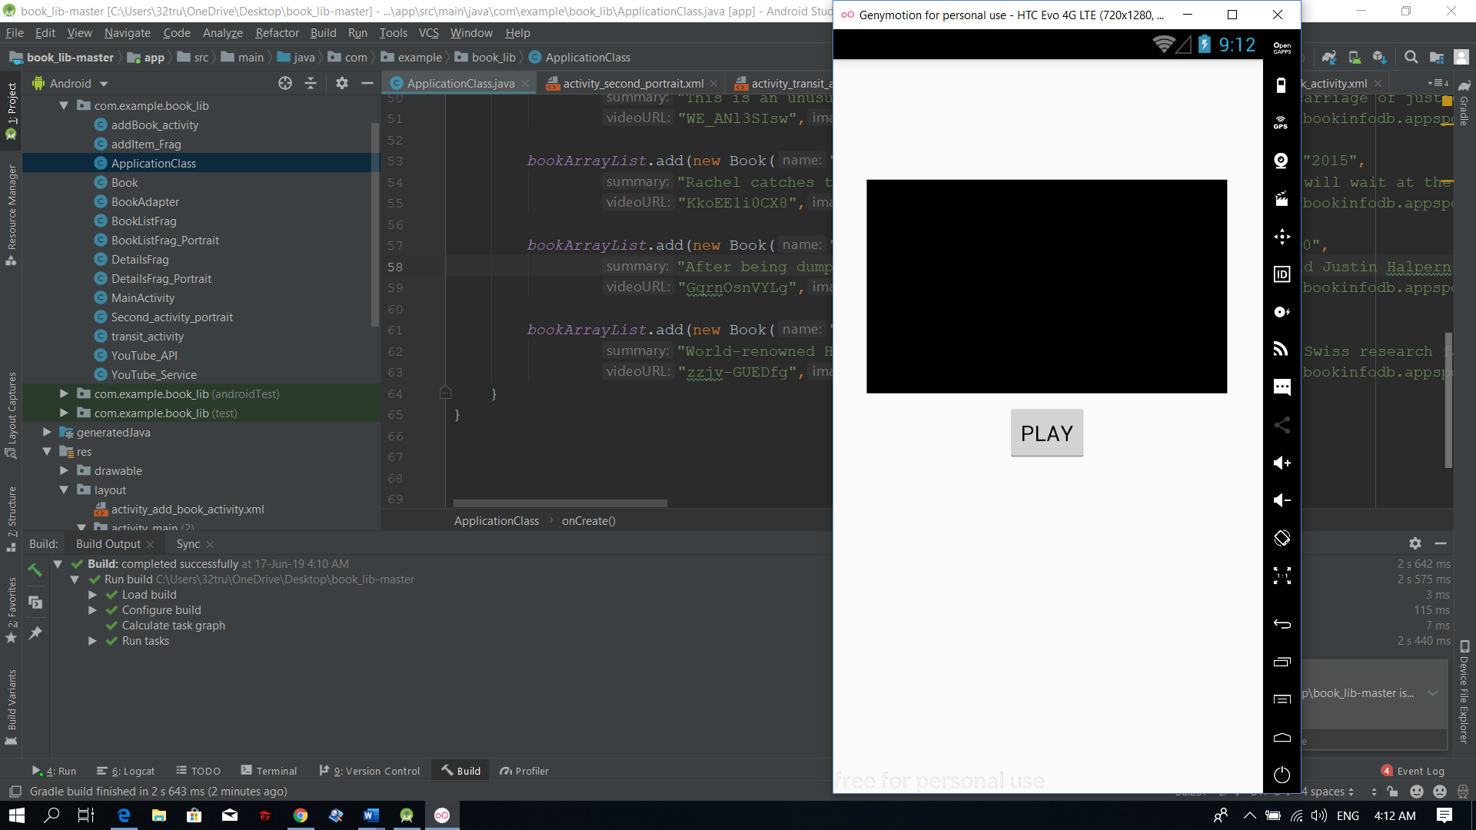

Custom Divider

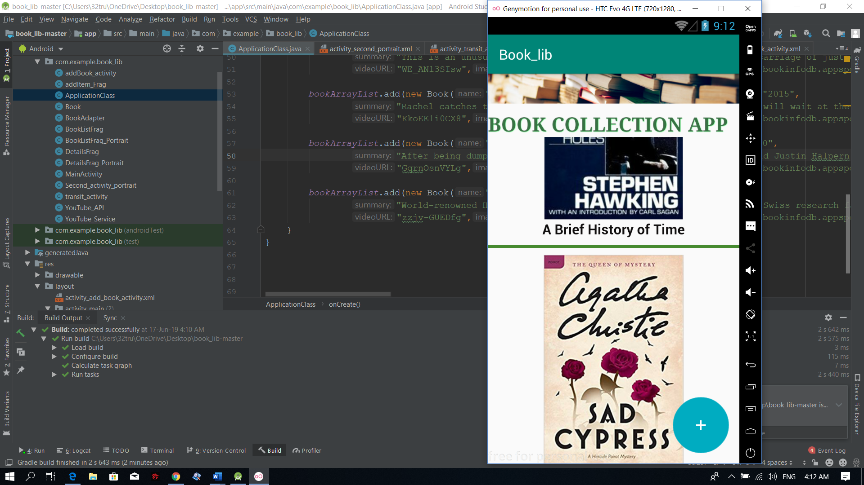

………

# Screenshots

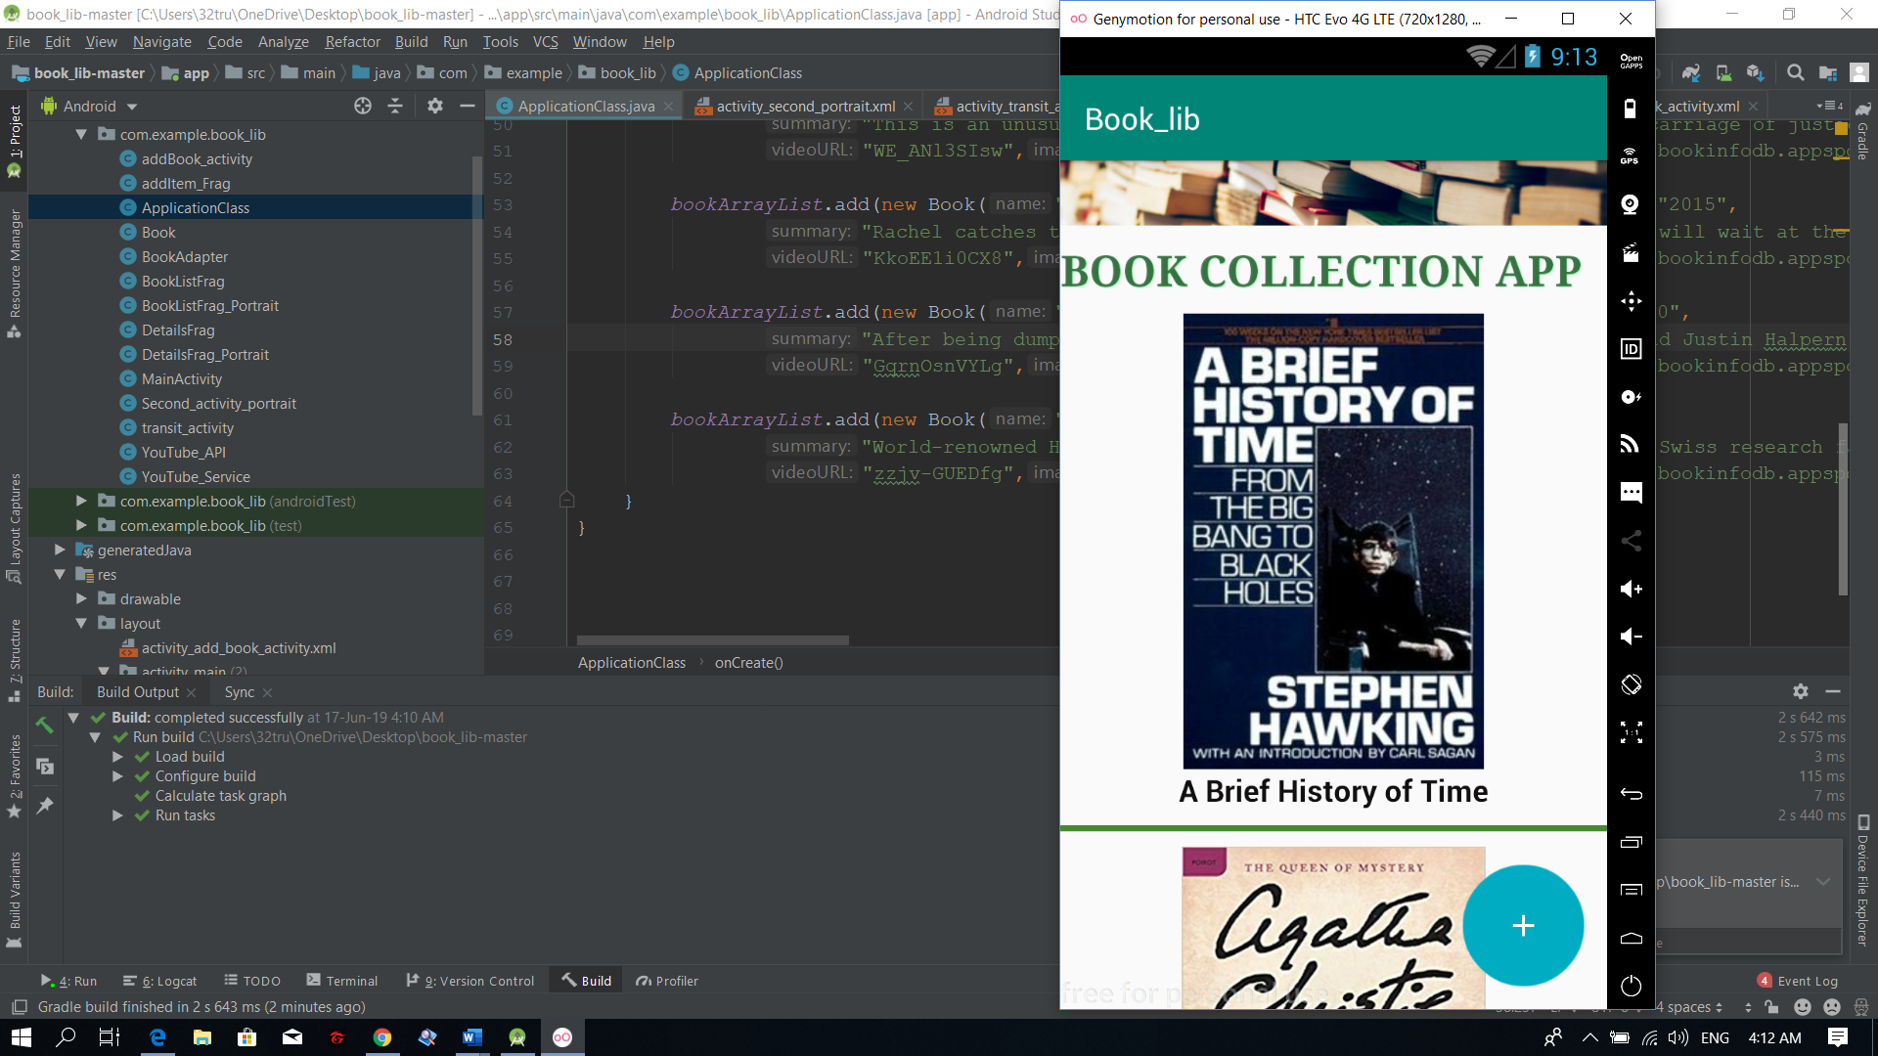

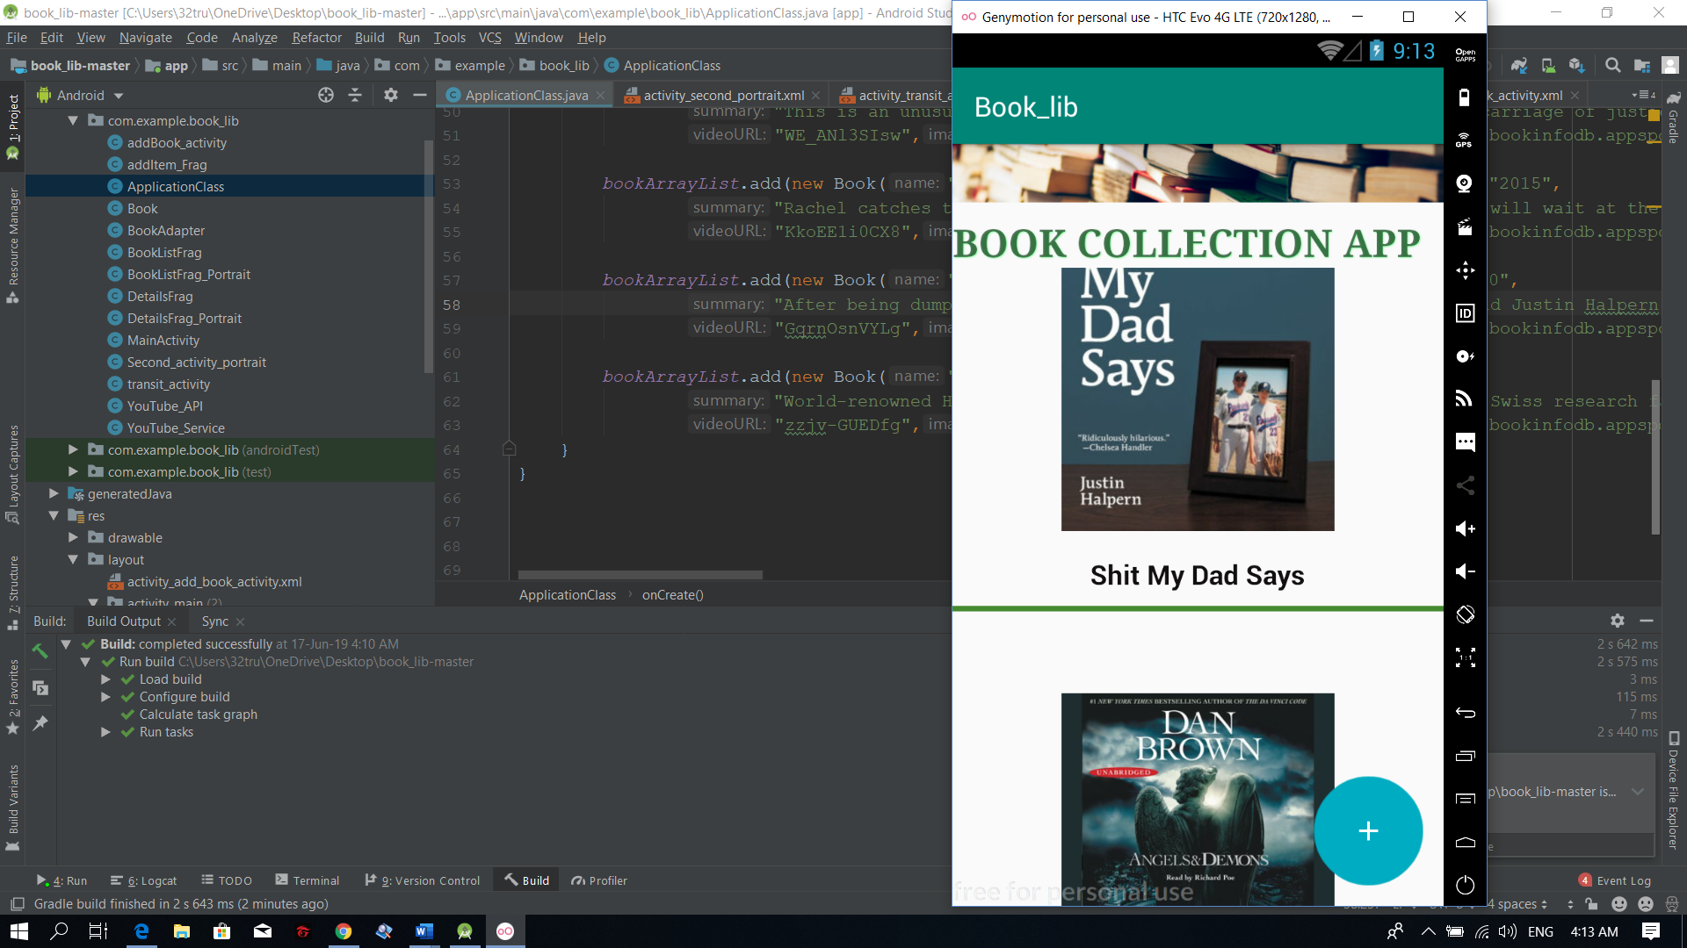

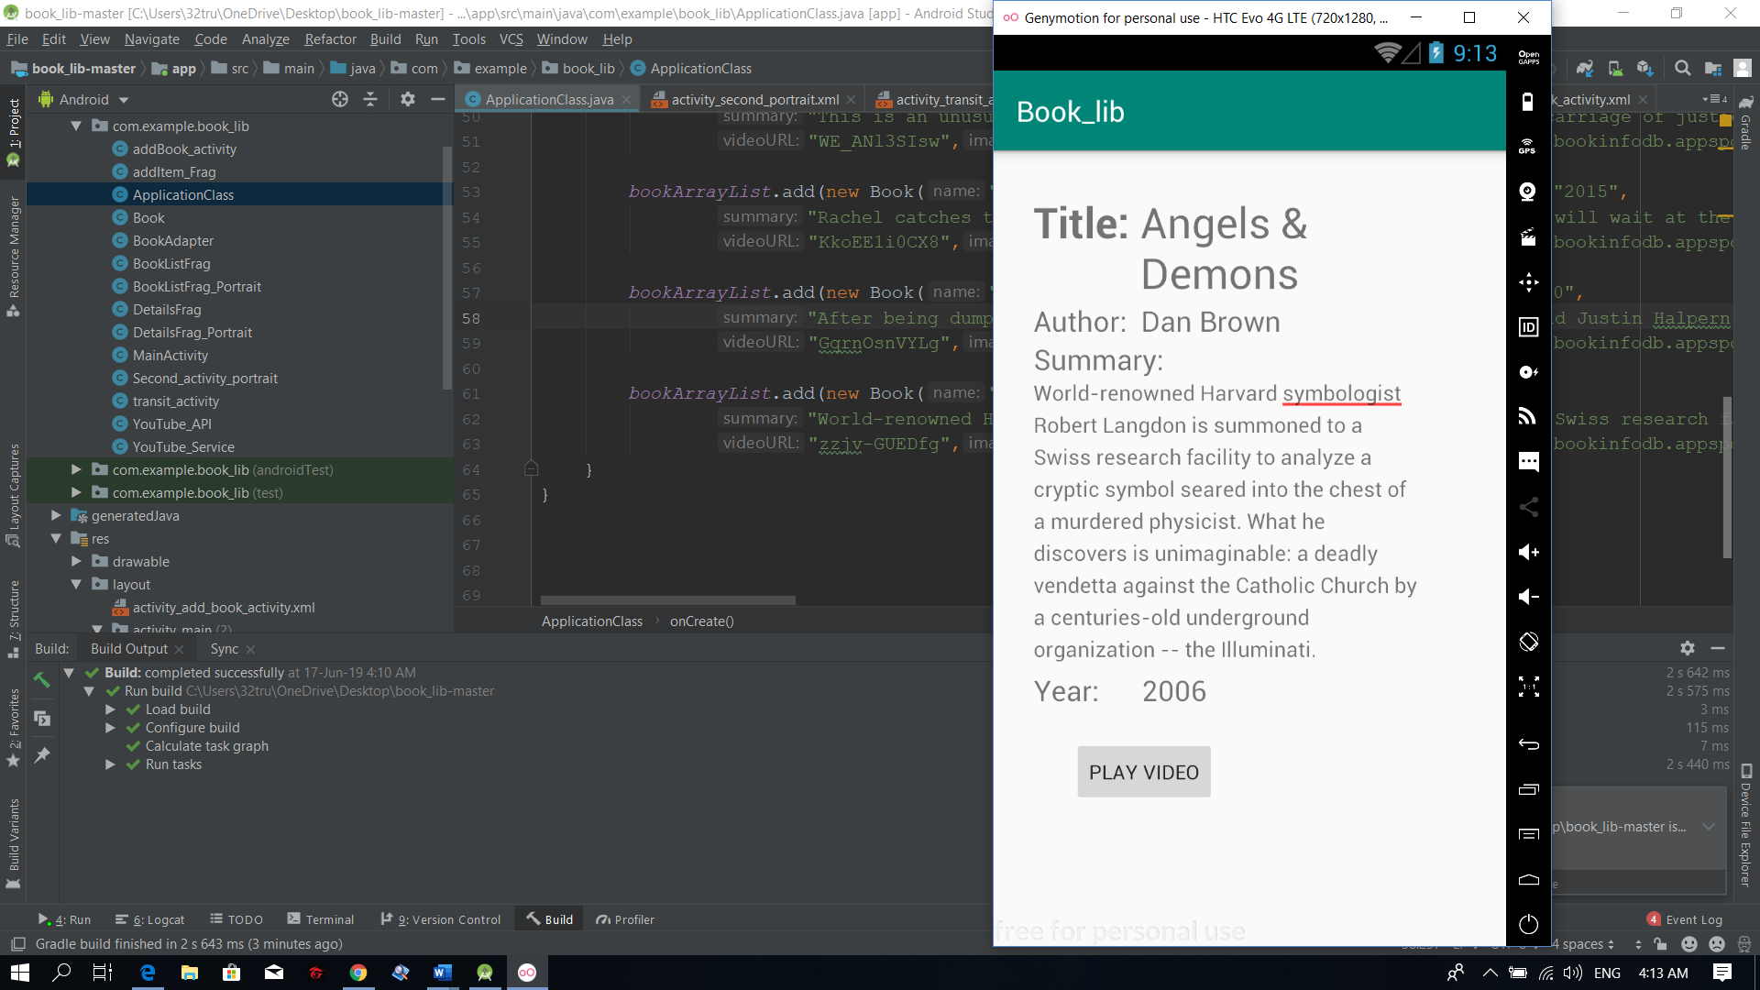

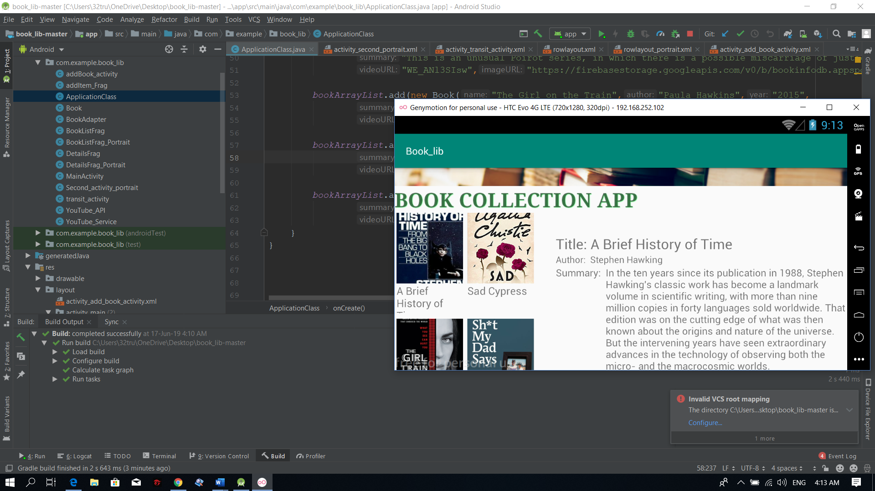

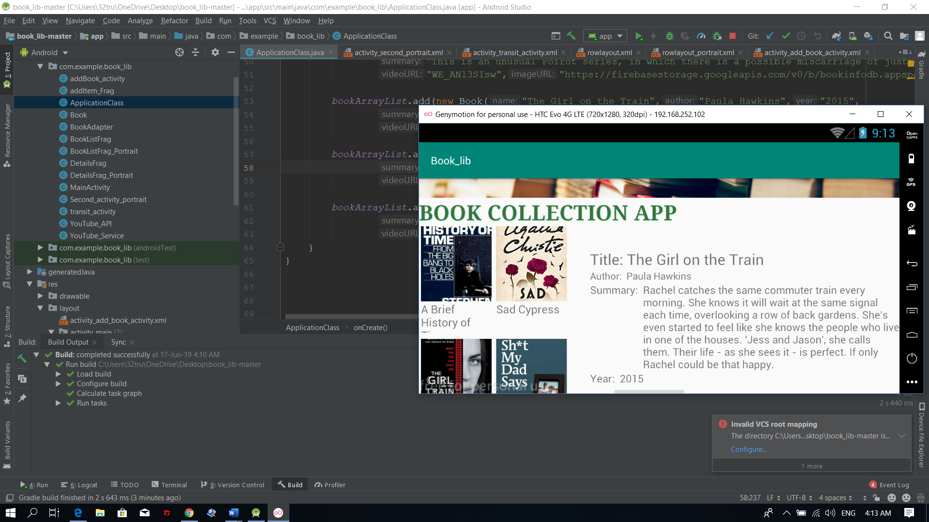

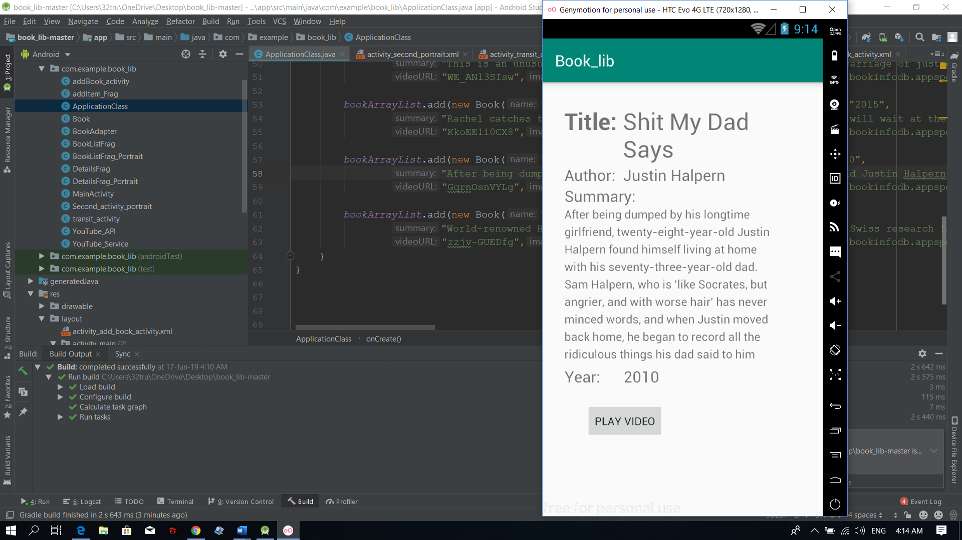

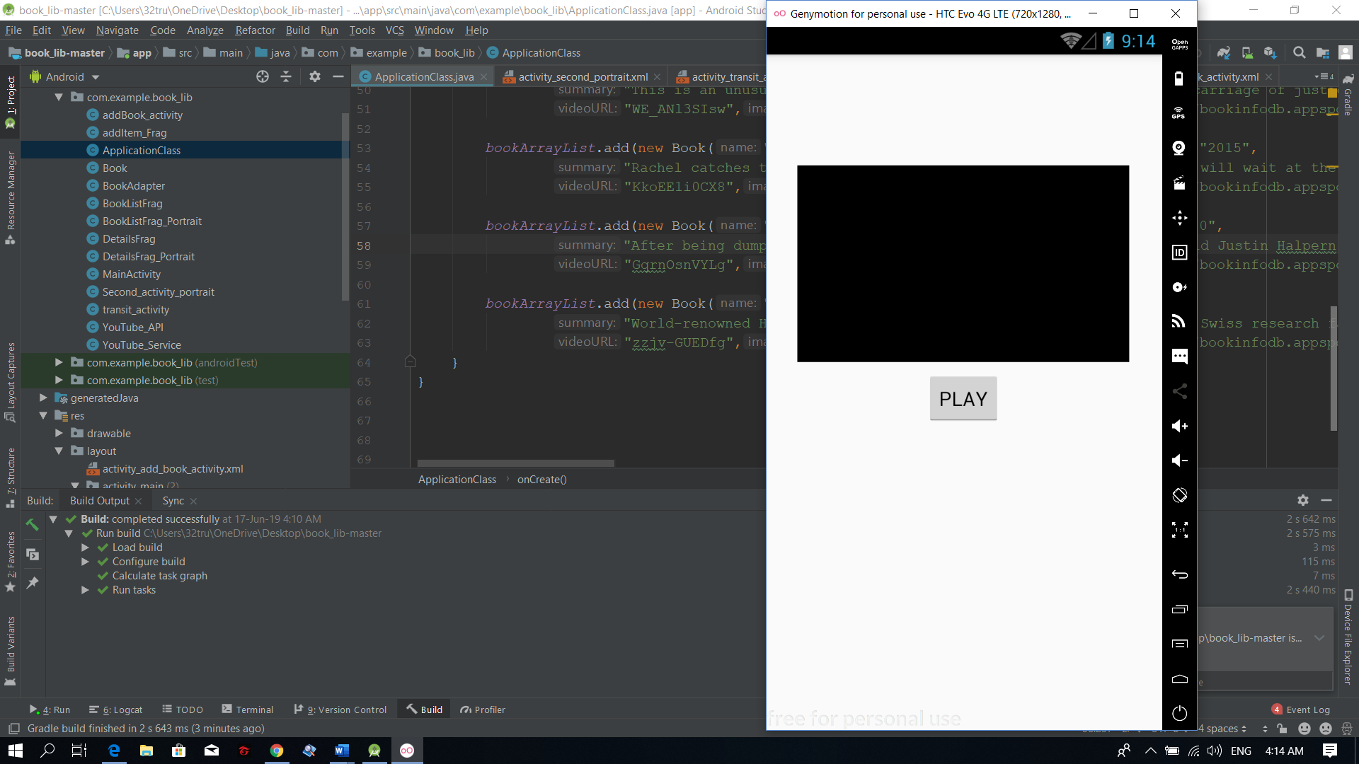

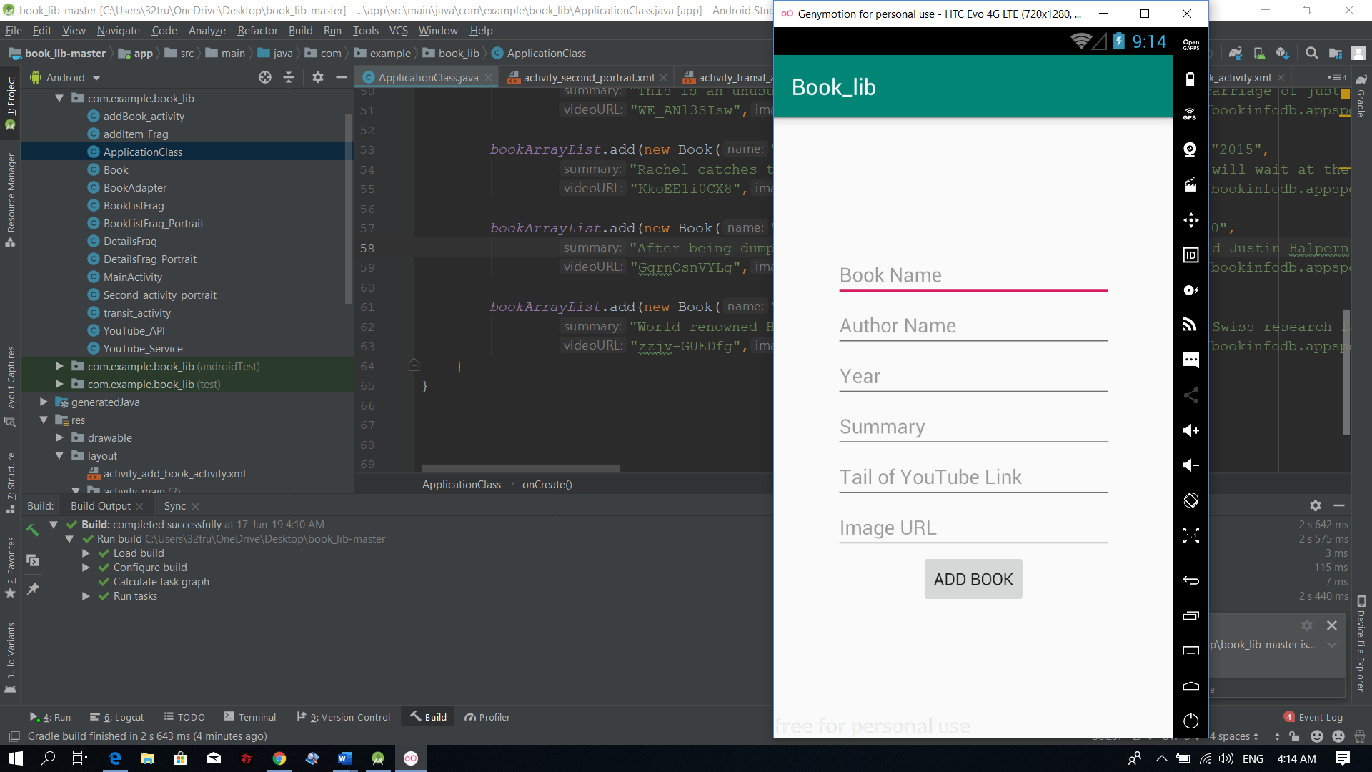

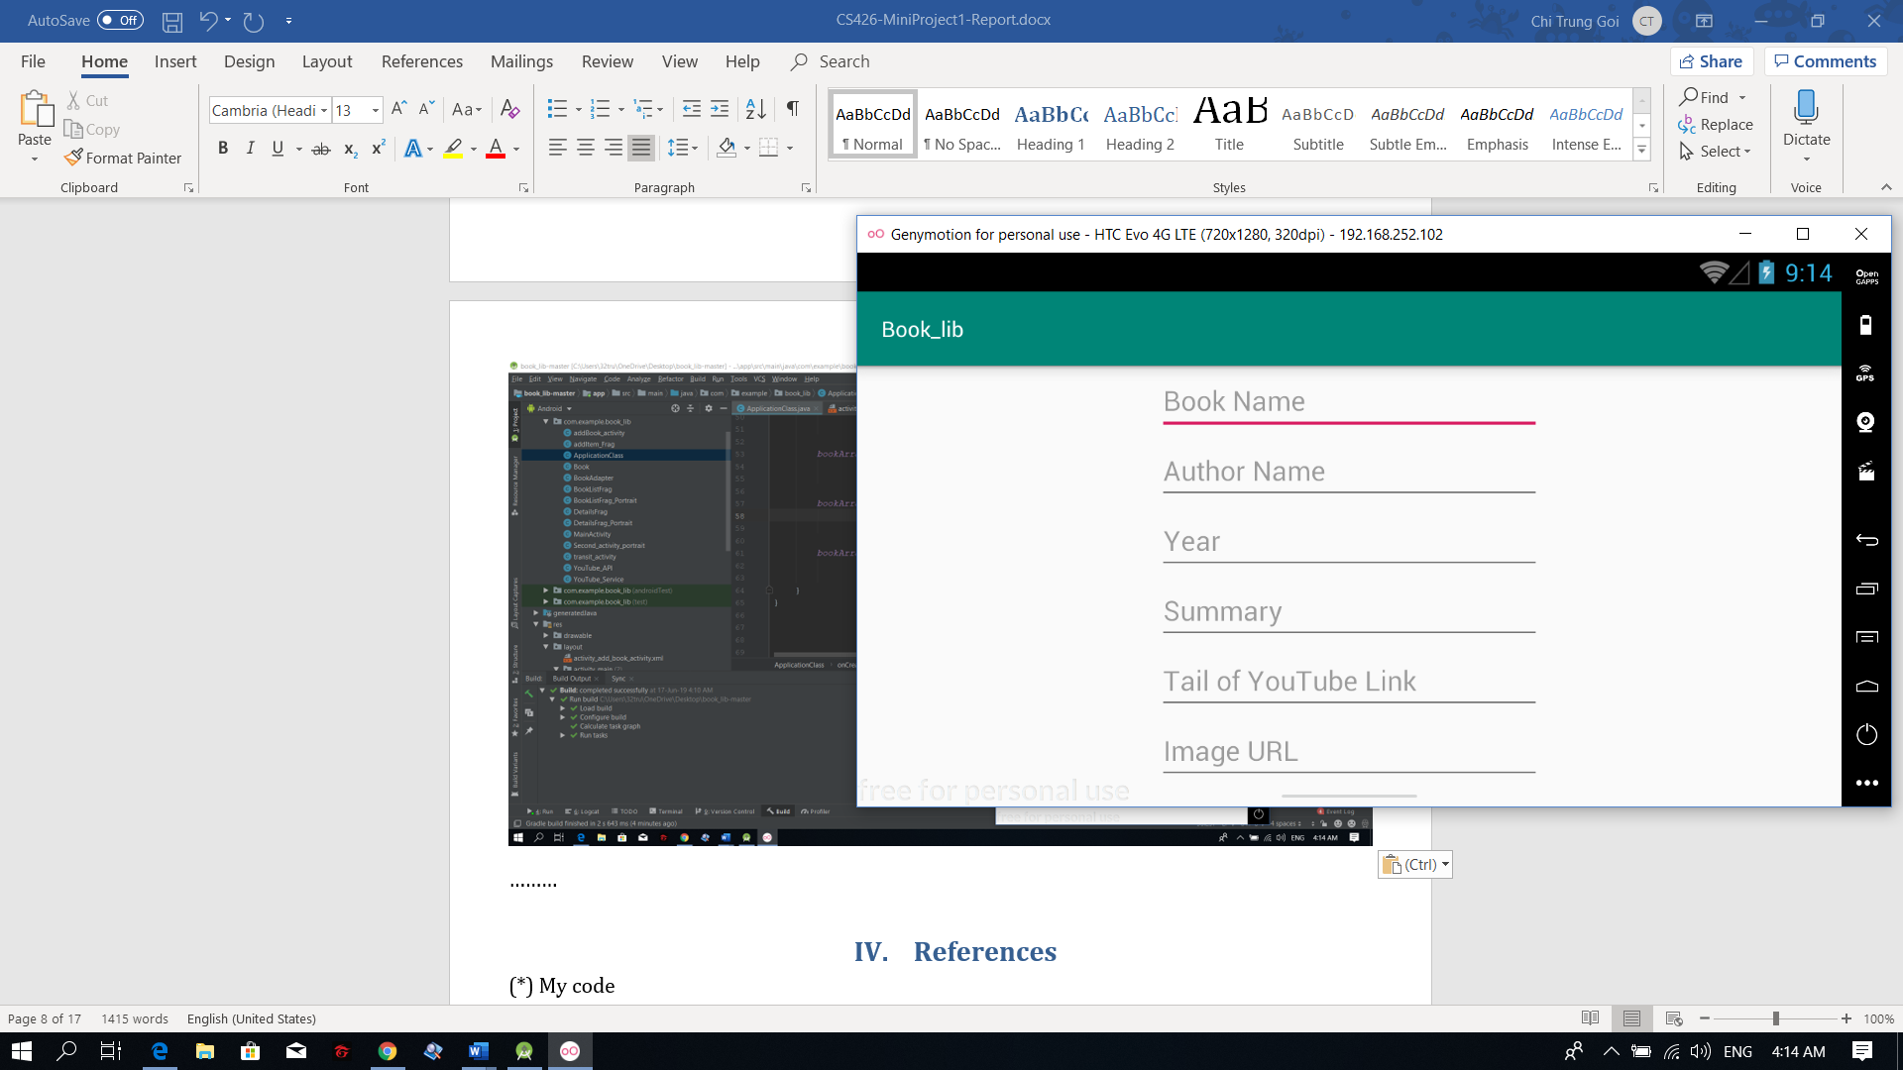

………

# References

(*) My code

package com.example.book_lib;  
  
  
import android.os.Bundle;  
import android.support.annotation.NonNull;  
import android.support.annotation.Nullable;  
import android.support.v4.app.Fragment;  
import android.support.v7.widget.GridLayoutManager;  
import android.support.v7.widget.LinearLayoutManager;  
import android.support.v7.widget.RecyclerView;  
import android.view.LayoutInflater;  
import android.view.View;  
import android.view.ViewGroup;  
  
  
*/**  
 * A simple {****@link*** *Fragment} subclass.  
 */*public class BookListFrag_Portrait extends Fragment {  
  
 RecyclerView recyclerView;  
 RecyclerView.Adapter myAdapter;  
 RecyclerView.LayoutManager layoutManager;  
 View view;  
 public BookListFrag_Portrait() {  
 // Required empty public constructor  
 }  
  
  
 @Override  
 public View onCreateView(LayoutInflater inflater, ViewGroup container,  
 Bundle savedInstanceState) {  
 // Inflate the layout for this fragment  
 view=inflater.inflate(R.layout.*fragment_book_list_frag__portrait*, container, false);  
 return view;  
 }  
  
 @Override  
 public void onViewCreated(@NonNull View view, @Nullable Bundle savedInstanceState) {  
 super.onViewCreated(view, savedInstanceState);  
 recyclerView=view.findViewById(R.id.*listBooksPortrait*);  
 recyclerView.setHasFixedSize(true);  
 layoutManager=new LinearLayoutManager(this.getActivity(),LinearLayoutManager.*VERTICAL*,false);  
 recyclerView.setLayoutManager(layoutManager);  
  
 myAdapter=new BookAdapter(this.getActivity(),ApplicationClass.*bookArrayList*);  
 recyclerView.setAdapter(myAdapter);  
 }  
 public void notifyDataChanged(){  
 myAdapter.notifyDataSetChanged();  
 }  
}

package com.example.book_lib;  
  
  
import android.os.Bundle;  
import android.support.v4.app.Fragment;  
import android.view.LayoutInflater;  
import android.view.View;  
import android.view.ViewGroup;  
  
  
*/**  
 * A simple {****@link*** *Fragment} subclass.  
 */*public class DetailsFrag_Portrait extends Fragment {  
  
  
 public DetailsFrag_Portrait() {  
 // Required empty public constructor  
 }  
  
  
 @Override  
 public View onCreateView(LayoutInflater inflater, ViewGroup container,  
 Bundle savedInstanceState) {  
 // Inflate the layout for this fragment  
 return inflater.inflate(R.layout.*fragment_details_frag__portrait*, container, false);  
 }  
  
}

package com.example.book_lib;  
  
import android.content.Intent;  
import android.support.v7.app.AppCompatActivity;  
import android.os.Bundle;  
import android.view.View;  
import android.widget.Button;  
import android.widget.TextView;  
  
public class Second_activity_portrait extends AppCompatActivity implements BookAdapter.ItemClicked {  
 TextView nameFrag,authorFrag,summaryFrag;  
 TextView yearFrag;  
 Button reviewBtn;  
 @Override  
 protected void onCreate(Bundle savedInstanceState) {  
 super.onCreate(savedInstanceState);  
 setContentView(R.layout.*activity_second_portrait*);  
  
 System.*out*.println("Portrait mode");  
 Intent intent=getIntent();  
 int bookIndex=intent.getIntExtra(BookAdapter.*EXTRA_INDEX*,0);  
 nameFrag = findViewById(R.id.*nameBookFragPortrait*);  
 authorFrag = findViewById(R.id.*authorFragPortrait*);  
 summaryFrag = findViewById(R.id.*summaryFragPortrait*);  
 yearFrag=findViewById(R.id.*yearFragPortrait*);  
 reviewBtn=findViewById(R.id.*reviewBtnPortrait*);  
 onItemClicked(bookIndex);  
 reviewBtn.setOnClickListener(new View.OnClickListener() {  
 @Override  
 public void onClick(View v) {  
 openYoutubeReviewActivity();  
 }  
 });  
  
 }  
  
 private void openYoutubeReviewActivity() {  
 Intent intent = new Intent(this,YouTube_API.class);  
 startActivity(intent);  
 }  
  
 @Override  
 public void onItemClicked(int index) {  
 nameFrag.setText(ApplicationClass.*bookArrayList*.get(index).getName());  
 authorFrag.setText(ApplicationClass.*bookArrayList*.get(index).getAuthor());  
 summaryFrag.setText(ApplicationClass.*bookArrayList*.get(index).getSummary());  
 yearFrag.setText(ApplicationClass.*bookArrayList*.get(index).getYear());  
 }  
}

<?xml version="1.0" encoding="utf-8"?>  
<LinearLayout xmlns:android="http://schemas.android.com/apk/res/android"  
 android:orientation="vertical"  
 android:layout_width="match_parent"  
 android:layout_height="wrap_content"  
 android:layout_marginVertical="10dp"  
 >  
  
 <ImageView  
 android:src="@mipmap/ic_launcher"  
 android:layout_gravity="center"  
 android:id="@+id/bookImgPortrait"  
 android:layout_width="200dp"  
 android:layout_height="300dp" />  
 <TextView  
 android:textColor="#110F0F"  
 android:textStyle="bold"  
 android:id="@+id/bookNamePortrait"  
 android:layout_width="wrap_content"  
 android:layout_height="wrap_content"  
 android:text="Book Name"  
 android:layout_gravity="center"  
 android:textSize="20sp"/>  
  
</LinearLayout>

<?xml version="1.0" encoding="utf-8"?>  
<LinearLayout xmlns:android="http://schemas.android.com/apk/res/android"  
 xmlns:app="http://schemas.android.com/apk/res-auto"  
 xmlns:tools="http://schemas.android.com/tools"  
 android:id="@+id/relativeLayout2"  
 android:layout_width="match_parent"  
 android:layout_height="match_parent"  
 android:orientation="vertical">  
  
 <LinearLayout  
 android:layout_width="371dp"  
 android:layout_height="wrap_content"  
 android:layout_marginLeft="8dp"  
 android:layout_marginTop="30dp"  
 android:layout_marginBottom="8dp"  
 android:orientation="vertical"  
 android:paddingLeft="20dp"  
 app:layout_constraintBottom_toBottomOf="parent"  
 app:layout_constraintEnd_toEndOf="parent"  
 app:layout_constraintHorizontal_bias="0.368"  
 app:layout_constraintStart_toStartOf="parent"  
 app:layout_constraintTop_toTopOf="parent"  
 app:layout_constraintVertical_bias="0.172">  
  
 <LinearLayout  
 android:layout_width="match_parent"  
 android:layout_height="wrap_content"  
 android:orientation="horizontal">  
  
 <TextView  
 android:layout_width="wrap_content"  
 android:layout_height="match_parent"  
 android:text="Title: "  
 android:textSize="20dp" />  
  
 <TextView  
 android:id="@+id/nameBookFragPortrait"  
 android:layout_width="wrap_content"  
 android:layout_height="match_parent"  
 android:textSize="20dp"  
 app:layout_constraintEnd_toStartOf="parent"  
 app:layout_constraintStart_toStartOf="parent"  
 app:layout_constraintTop_toTopOf="parent" />  
 </LinearLayout>  
  
 <LinearLayout  
 android:layout_width="match_parent"  
 android:layout_height="wrap_content"  
 android:orientation="horizontal">  
  
 <TextView  
 android:layout_width="wrap_content"  
 android:layout_height="match_parent"  
 android:text="Author: "  
 android:textSize="13dp" />  
  
 <TextView  
 android:id="@+id/authorFragPortrait"  
 android:layout_width="wrap_content"  
 android:layout_height="match_parent"  
 android:textSize="13dp"  
 app:layout_constraintEnd_toStartOf="parent"  
 app:layout_constraintStart_toStartOf="parent"  
 app:layout_constraintTop_toBottomOf="@+id/nameBookFragPortrait" />  
 </LinearLayout>  
  
  
 <LinearLayout  
 android:layout_width="match_parent"  
 android:layout_height="wrap_content">  
  
 <TextView  
 android:layout_width="wrap_content"  
 android:layout_height="match_parent"  
 android:text="Summary: " />  
  
 <TextView  
 android:id="@+id/summaryFragPortrait"  
 android:layout_width="match_parent"  
 android:layout_height="wrap_content" />  
 </LinearLayout>  
  
 <LinearLayout  
 android:layout_width="match_parent"  
 android:layout_height="wrap_content">  
  
 <TextView  
 android:layout_width="wrap_content"  
 android:layout_height="match_parent"  
 android:text="Year: " />  
  
 <TextView  
 android:id="@+id/yearFragPortrait"  
 android:layout_width="match_parent"  
 android:layout_height="wrap_content" />  
  
 </LinearLayout>  
  
 <Button  
 android:id="@+id/reviewBtnPortrait"  
 android:layout_width="wrap_content"  
 android:layout_height="wrap_content"  
 android:layout_marginLeft="27dp"  
 android:text="PLAY VIDEO" />  
  
 </LinearLayout>  
</LinearLayout>

<?xml version="1.0" encoding="utf-8"?>  
<shape xmlns:android="http://schemas.android.com/apk/res/android">  
 <size android:width="3dp"  
 android:height="4dp"/>  
 <solid android:color="#468A30"/>  
</shape>

<?xml version="1.0" encoding="utf-8"?>  
<shape xmlns:android="http://schemas.android.com/apk/res/android"  
 android:shape="rectangle" >  
 <solid android:color="@android:color/white" />  
 <stroke android:width="1dip"  
 android:color="#4fa5d5"/>  
</shape>

References : Firebase Database Documentation

package com.example.book_lib;  
  
import android.app.Application;  
import android.content.Context;  
import android.net.Uri;  
import android.support.annotation.NonNull;  
import android.support.annotation.Nullable;  
import android.widget.Toast;  
  
import com.google.android.gms.tasks.OnFailureListener;  
import com.google.android.gms.tasks.OnSuccessListener;  
import com.google.firebase.FirebaseApp;  
import com.google.firebase.database.ChildEventListener;  
import com.google.firebase.database.DataSnapshot;  
import com.google.firebase.database.DatabaseError;  
import com.google.firebase.database.DatabaseReference;  
import com.google.firebase.database.FirebaseDatabase;  
import com.google.firebase.storage.FirebaseStorage;  
import com.google.firebase.storage.StorageReference;  
  
import java.util.ArrayList;  
  
public class ApplicationClass extends Application {  
 public static ArrayList<Book> *bookArrayList*;  
  
 DatabaseReference mData;  
 String mName="";  
  
 FirebaseStorage storage = FirebaseStorage.*getInstance*();  
  
 @Override  
 public void onCreate() {  
 super.onCreate();  
 *bookArrayList*=new ArrayList<>();  
 FirebaseApp.*initializeApp*(this);  
  
 mData = FirebaseDatabase.*getInstance*().getReference();  
 final StorageReference storageRef = storage.getReferenceFromUrl("gs://bookinfodb.appspot.com");  
 getImage(storageRef);  
 initBookData(mData);  
 }  
  
 private void initBookData(DatabaseReference mData) {  
 mData.child("BookName").addChildEventListener(new ChildEventListener() {  
 @Override  
 public void onChildAdded(@NonNull DataSnapshot dataSnapshot, @Nullable String s) {  
 Book dataBook = dataSnapshot.getValue(Book.class);  
 *bookArrayList*.add(new Book(dataBook.getName(), dataBook.getAuthor(), dataBook.getYear(), dataBook.getSummary(), dataBook.getVideoURL(), dataBook.getImageURL()));  
 //bookAdapter.notifyDataSetChanged();  
 //Toast.makeText(MainActivity.this, dataSnapshot.getKey(), Toast.LENGTH_SHORT).show();  
  
 }  
  
 @Override  
 public void onChildChanged(@NonNull DataSnapshot dataSnapshot, @Nullable String s) {  
  
 }  
  
 @Override  
 public void onChildRemoved(@NonNull DataSnapshot dataSnapshot) {  
  
 }  
  
 @Override  
 public void onChildMoved(@NonNull DataSnapshot dataSnapshot, @Nullable String s) {  
  
 }  
  
 @Override  
 public void onCancelled(@NonNull DatabaseError databaseError) {  
  
 }  
  
 });  
  
}  
 public void getImage (StorageReference storageRef){  
  
 storageRef.child("briefhistoryoftime.png").getDownloadUrl().addOnSuccessListener(new OnSuccessListener<Uri>() {  
 @Override  
 public void onSuccess(Uri uri) {  
 Book book = new Book("A Brief History Of Time","Stephen Hawking","1988",  
 "In the ten years since its publication in 1988, Stephen Hawking's classic work has become a landmark volume in scientific writing, with more than nine million copies in forty languages sold worldwide. That edition was on the cutting edge of what was then known about the origins and nature of the universe. But the intervening years have seen extraordinary advances in the technology of observing both the micro- and the macrocosmic worlds.",  
 "OH83zM_YoUE",uri.toString());  
 mData.child("BookName").push().setValue(book);  
 // Got the download URL for 'users/me/profile.png'  
 }  
 }).addOnFailureListener(new OnFailureListener() {  
 @Override  
 public void onFailure(@NonNull Exception exception) {  
 Toast.*makeText*(ApplicationClass.this, "Fail to load", Toast.*LENGTH_SHORT*).show();  
 }  
 });  
 }  
  
}  
  
  
  
// bookArrayList.add(new Book("A Brief History of Time","Stephen Hawking","1988","In the ten years since its publication in 1988, Stephen Hawking&#39;s classic work has\n" +  
// "become a landmark volume in scientific writing,..","OH83zM_YoUE"));  
//  
// bookArrayList.add(new Book("Sad Cypress","Agatha Christie","1940","This is an unusual Poirot series, in which there is a possible miscarriage of justice.\n" +  
// "With a beautiful title taken from Shakespeare&#39;s &#39;Twelfth Night&#39;,,...","WE_ANl3SIsw"));  
//  
// bookArrayList.add(new Book("The Girl on the Train","Paula Hawkins","2015","Rachel catches the same commuter train every morning. She knows it will wait at\n" +  
// "the same signal each time, overlooking a row of back gardens....","KkoEE1i0CX8"));  
//  
// bookArrayList.add(new Book("Shit My Dad Says","Justin Halpern","2010","After being dumped by his longtime girlfriend, twenty-eight-year-old Justin\n" +  
// "Halpern found himself living at home with his seventy-three-year-old dad....","GqrnOsnVYLg"));  
//  
// bookArrayList.add(new Book("Angels & Demons","Dan Brown","2006","World-renowned Harvard symbologist Robert Langdon is summoned to a Swiss\n" +  
// "research facility to analyze a cryptic symbol seared into the chest of...","zzjv-GUEDfg"));

package com.example.book_lib;  
  
public class Book {  
 private String name;  
 private String author;  
 private String year;  
 private String summary;  
 private String videoURL;  
 private String imageURL;  
  
// public Book(String name, String author, String summary) {  
// this.name = name;  
// this.author = author;  
// this.summary = summary;  
// }  
//  
// public String getName() {  
// return name;  
// }  
//  
// public void setName(String name) {  
// this.name = name;  
// }  
//  
// public String getAuthor() {  
// return author;  
// }  
//  
// public void setAuthor(String author) {  
// this.author = author;  
// }  
//  
// public String getSummary() {  
// return summary;  
// }  
//  
// public void setSummary(String summary) {  
// this.summary = summary;  
// }  
  
 public Book(String name, String author, String year, String summary, String videoURL, String imageURL) {  
 this.name = name;  
 this.author = author;  
 this.year = year;  
 this.summary = summary;  
 this.videoURL = videoURL;  
 this.imageURL = imageURL;  
 }  
  
 public String getImageURL() {  
 return imageURL;  
 }  
  
 public void setImageURL(String imageURL) {  
 this.imageURL = imageURL;  
 }  
  
 public String getName() {  
 return name;  
 }  
  
 public void setName(String name) {  
 this.name = name;  
 }  
  
 public String getAuthor() {  
 return author;  
 }  
  
 public void setAuthor(String author) {  
 this.author = author;  
 }  
  
 public String getYear() {  
 return year;  
 }  
  
 public void setYear(String year) {  
 this.year = year;  
 }  
  
 public String getSummary() {  
 return summary;  
 }  
  
 public void setSummary(String summary) {  
 this.summary = summary;  
 }  
  
 public String getVideoURL() {  
 return videoURL;  
 }  
  
 public void setVideoURL(String videoURL) {  
 this.videoURL = videoURL;  
 }  
}

implementation 'com.android.support:design:28.0.0'  
implementation 'com.google.firebase:firebase-database:17.0.0'  
implementation 'com.google.firebase:firebase-auth:16.0.4'  
implementation 'com.google.firebase:firebase-storage:17.0.0'  
implementation 'com.google.firebase:firebase-core:16.0.9'  
implementation 'com.squareup.picasso:picasso:2.71828'  
implementation files('libs/YouTubeAndroidPlayerApi.jar'

References: Youtube

package com.example.book_lib;  
  
import android.content.Intent;  
import android.support.v7.app.AppCompatActivity;  
import android.os.Bundle;  
import android.view.View;  
import android.widget.Button;  
  
import com.google.android.youtube.player.YouTubeBaseActivity;  
import com.google.android.youtube.player.YouTubeInitializationResult;  
import com.google.android.youtube.player.YouTubePlayer;  
import com.google.android.youtube.player.YouTubePlayerView;  
  
public class YouTube_API extends YouTubeBaseActivity {  
  
 YouTubePlayerView youTubePlayerView;  
 Button playBtn;  
 YouTubePlayer.OnInitializedListener onInitializedListener;  
 YouTube_Service service= new YouTube_Service();  
 @Override  
 protected void onCreate(Bundle savedInstanceState) {  
 super.onCreate(savedInstanceState);  
 Intent intent=getIntent();  
 final String url=intent.getStringExtra(MainActivity.*EXTRA_URL*);  
 setContentView(R.layout.*activity_you_tube__api*);  
 youTubePlayerView= findViewById(R.id.*reviewVideo*);  
 playBtn=findViewById(R.id.*playBtn*);  
 onInitializedListener=new YouTubePlayer.OnInitializedListener() {  
 @Override  
 public void onInitializationSuccess(YouTubePlayer.Provider provider, YouTubePlayer youTubePlayer, boolean b) {  
 youTubePlayer.loadVideo(url);  
 }  
  
 @Override  
 public void onInitializationFailure(YouTubePlayer.Provider provider, YouTubeInitializationResult youTubeInitializationResult) {  
  
 }  
 };  
 playBtn.setOnClickListener(new View.OnClickListener() {  
 @Override  
 public void onClick(View v) {  
 youTubePlayerView.initialize(service.getApi(),onInitializedListener);  
 }  
 });  
 }  
}

References: Android Developer Documentation and Code, Stackoverflow Code, Design Library, Google Services Library

………